National Ski Patrol

Service | 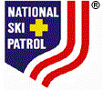 | Safety

This certifies that

Roger F. Langley
NSP# 000001

has completed all training requirements as outlined by the
National Ski Patrol and is hereby awarded the level of

Senior Alpine Patroller

Date  03/30/2005 |  | Patrol Director

