National Ski Patrol

Service | 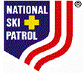 | Safety

This certifies that

Charles “Minnie” Dole

has completed all training requirements as outlined by the
National Ski Patrol and is hereby awarded the level of

Senior Alpine Patroller

Date  03/30/2003 |  | Patrol Director

