National Ski Patrol

Service | 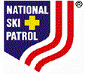 | Safety

This certifies that

Charles “Minnie” Dole

has completed a National Ski Patrol education course in

Mountain Travel Rescue

Date  03/30/2003 |  | Instructor

